**Project Idea**

Is there a particular film you want to see now! Tired of trying to find something that fits with your busy schedule? Type a movie title into the field below (please make sure it is spelled correctly) and then click "submit". We can tell you where it is and when it shows. Go to a local movie, stream or watch it on a local cable station! But watch it when it’s convenient for you!

OR our leadership department can give you our favorite shows OR search by genre.,

Be sure to also consider visiting our **Who Got It blog** where you can post your suggestions and discuss them with other fans and review trailers to determine what’s hot and what’s not.

**API Research**

* + <https://api.guidebox.com/>
  + <https://developers.themoviedb.org/3/genres/get-movie-list>
  + Rotten Tomatoes- Requires proposal – In progress

**Initial draft / sketch of the final design**

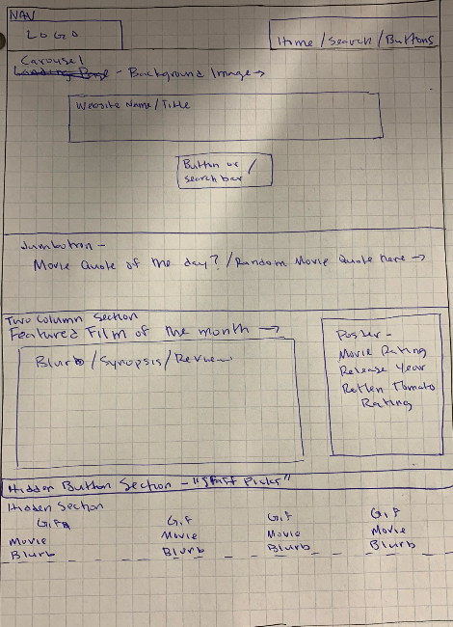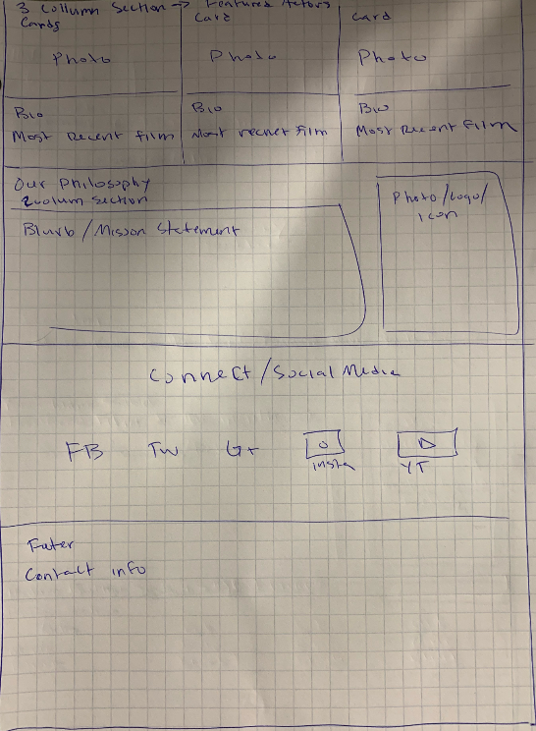

**Proposal listing out each of the following:**

* + Title “Who Gots It”
  + Team Members – Jon/Alan-Joe/Max
  + Sketch of Final Product - In progress
  + APIs to be Used
    - See Research above

**Rough Breakdown of Tasks**

* Front End Jon / Steve
* Back End Max / Alan

Web sites to review

* + - <https://www.snagfilms.com/>
    - <https://www.popcornflix.com>
    - <http://www.tcm.com/suggest-a-movie/>